Setup Ngrok and get the API Key - Create a free account and generate a auth token
Setup URL - https://dashboard.ngrok.com/get-started/setup/macos
Auth Token Creation URL - https://dashboard.ngrok.com/authtokens

Please check out the project and run the containers.

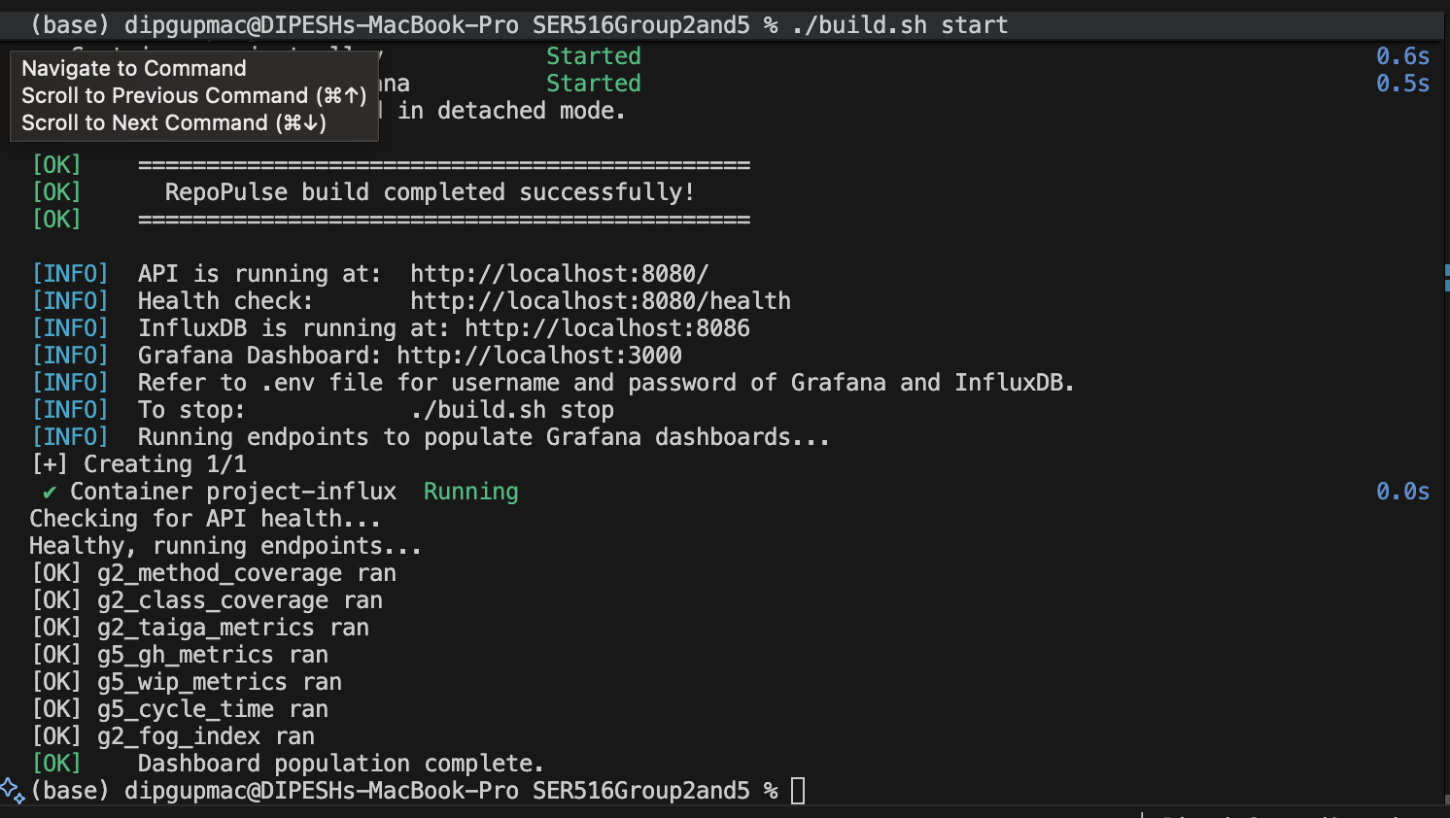

Next open a new terminal and run the ngrok command
Check if ngrok available → ngrok version
Install if ngrok unavailable → brew reinstall --cask ngrok
Add the auth token in the terminal - ngrok config add-authtoken 3CPy1nQAkrPgIyGuY0Fbhef1eR9_6cav5MKcc8pZyQQqMNPD9(sample token please update the one generate above)
Run ngrok for influx DB - ngrok http 8086 --host-header="localhost:8086"

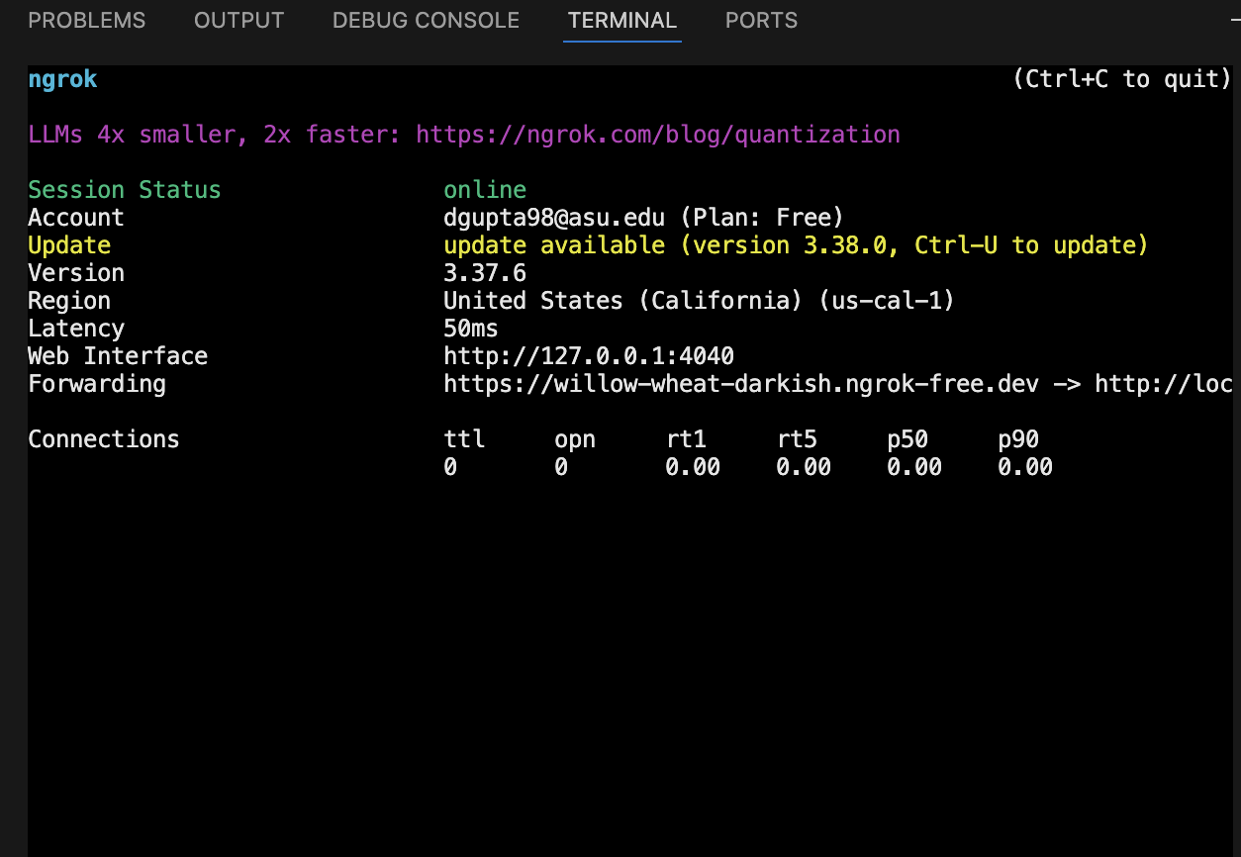

Copy the URL from the above terminal once the ngrok command runs and paste it in grafana influx DB link
Direct Link to update setting - https://swent0linux.asu.edu/grafana/connections/datasources/edit/efj7rb9wgl8u8a

Update the URL in Grafana setting
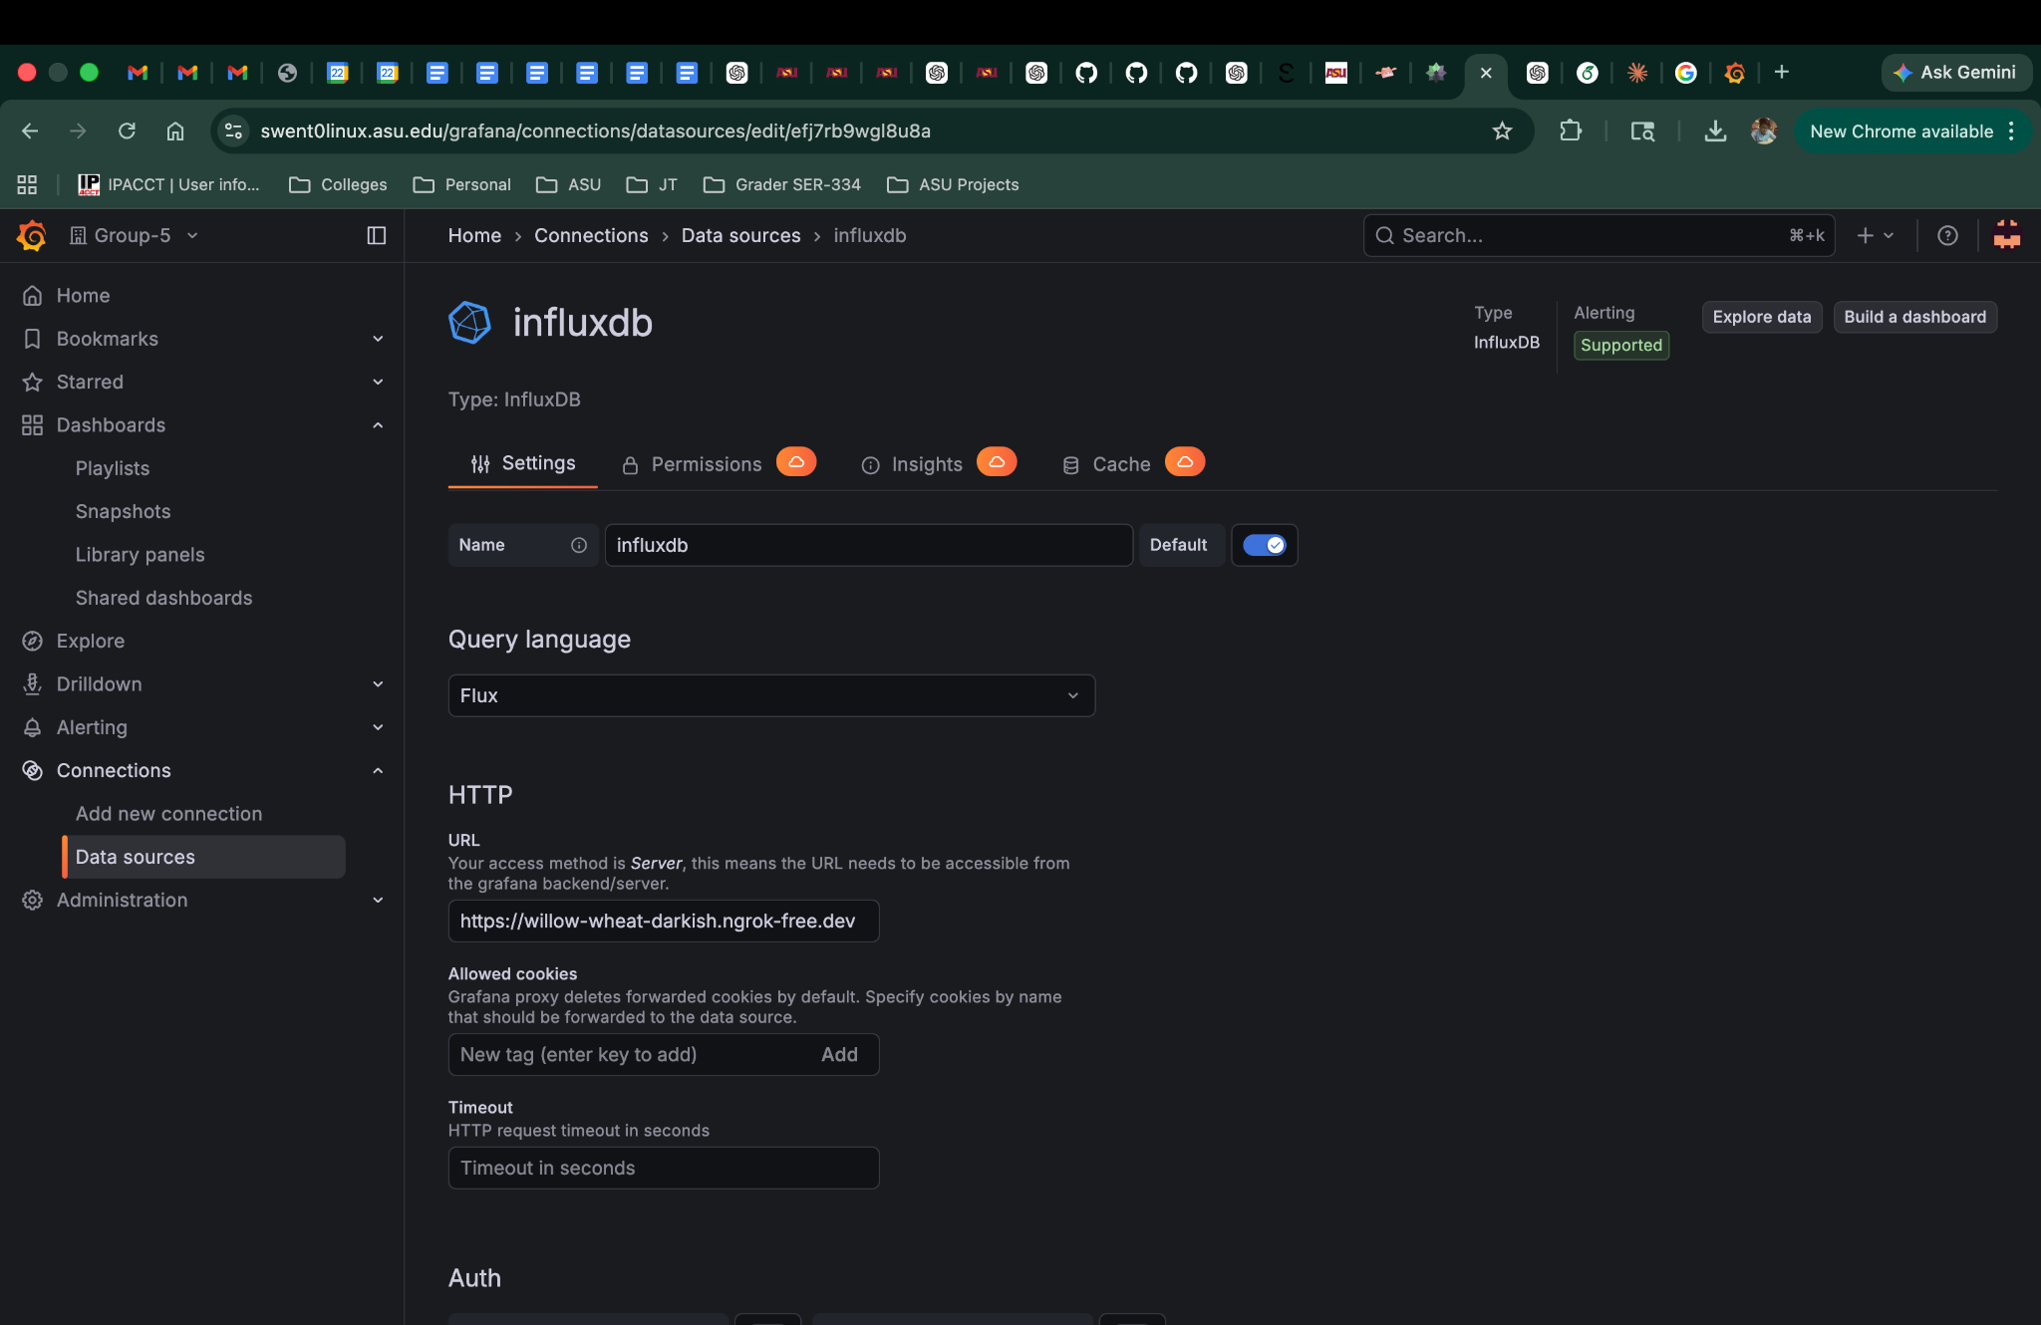
Save and Test from the button in Grafana at the bottom of the page.
Grafana Dashboards should come up data now
https://swent0linux.asu.edu/grafana/dashboards

Grafana Link to create dashboards
https://swent0linux.asu.edu/grafana/dashboard/import

From the repo Monitoring→ Dashboards→ copy the json and update in the above url

